# LAB # 01

**LAB TASKS 1:**

class Main {

public static void main(String[] args) {

String s1 = "Java";

String s2 = "Programming";

String s3 = new String("Programming");

String s4 = new String("Java").intern();

System.out.println((s1 == s2) + ", Strings are not equal."); // true

System.out.println((s1 == s3) + ", Strings are not equal."); // false

System.out.println((s1 == s4) + ", Strings are equal."); // true

}

}

**OUTPUT**

**LAB TASKS 2:**

public class Wrapper {

public static void main(String[] args) {

double M1=390;

Double M2=M1;

System.out.println("Wrapper Class:"+M2);

}

}

**OUTPUT**

**LAB TASKS 3:**

class Main {

public static void main(String[] args) {

String str1 = "Abdullah";

String str2 = "JAVA";

String str3 = "PythonProgramming";

String str4 = "dsa";

String str5 = "HTML";

//write the concat() method

str1.concat("Jalal");

str2.concat("OOP");

str3.concat("Programming");

str4.concat("Java");

str5.concat("FRONTEND");

System.out.println("string refer to:"+str1);

System.out.println("string refer to:"+str2);

System.out.println("string refer to:"+str3);

System.out.println("string refer to:"+str4);

System.out.println**("string refer to:"+str5);**

String str4Upper = str4.toUpperCase();

System.out.println("Fourth String in Uppercase: " + str4Upper);

String substring = str3.substring(2);

System.out.println("Substring from index 8 onwards: " + substring);

}

}

**OUTPUT**

**LAB TASKS 4:**

class Main {

public static String mergeAlternately(String word1, String word2) {

StringBuilder mergedString = new StringBuilder();

int i = 0,j=0;

// Alternate between the characters of both strings

while (i < word1.length() || j < word2.length()) {

if (i < word1.length()) {

mergedString.append(word1.charAt(i));

i++;

}

if (j < word2.length()) {

mergedString.append(word2.charAt(j));

j++;

}

}

return mergedString.toString();

}

public static void main(String[] args) {

// Example input

String word1 = "Adla";

String word2 = "bulh";

// Call the method to merge strings alternately

String result = mergeAlternately(word1, word2);

// Print the result

System.out.println("Merged String: " + result);

}

}

**OUTPUT**

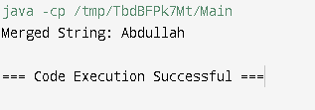

**LAB TASKS 5:**

public class MinMaxValues {

public static void main(String[] args) {

// Display the minimum and maximum values of Integer

System.out.println("Integer Minimum Value: " + Integer.MIN_VALUE);

System.out.println("Integer Maximum Value: " + Integer.MAX_VALUE);

// Display the minimum and maximum values of Float

System.out.println("Float Minimum Value: " + Float.MIN_VALUE);

System.out.println("Float Maximum Value: " + Float.MAX_VALUE);

// Display the minimum and maximum values of Double

System.out.println("Double Minimum Value: " + Double.MIN_VALUE);

System.out.println("Double Maximum Value: " + Double.MAX_VALUE);

}

}

**OUTPUT**

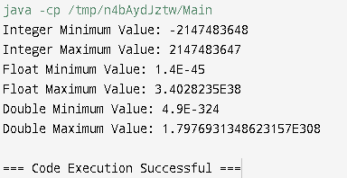

**HOME TASK 1:**

class Main {

public static void main(String[] args) {

int num= 5;

Integer wrapperdnum= num;

System.out.println("Autoboxed Integer:"+ wrapperdnum);

double num1= 46;

Double wrapperdnum1= num1;

System.out.println("Autoboxed Double:"+wrapperdnum1);

int unboxednum= wrapperdnum;

//using wrapper class method

System.out.println("byte value" + wrapperdnum.byteValue());

System.out.println("double value" + wrapperdnum.doubleValue());

System.out.println("String value" + wrapperdnum.toString());

}

}

**OUTPUT**

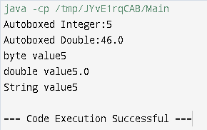

**HOME TASK 2:**

import java.util.Scanner;

public class EvenoddDigitCounter {

public static void main(String[] args) {

// Input integer from the user

Scanner scanner = new Scanner(System.in);

System.out.print("Enter an integer: ");

int inputNumber = scanner.nextInt();

// Variables to count even and odd digits

Integer evenCount = 0; // Autoboxing

Integer oddCount = 0; // Autoboxing

// Loop to count even and odd digits

while (inputNumber > 0) {

// Get the last digit using Unboxing

int digit = inputNumber % 10;

// Check if the digit is even or odd

if (digit % 2 == 0) {

evenCount++; // Unboxing and Increment

} else {

oddCount++; // Unboxing and Increment

}

// Remove the last digit

inputNumber = inputNumber / 10;

}

// Output the results

System.out.println("Number of Even Digits: " + evenCount); // Autoboxing to String

System.out.println("Number of Odd Digits: " + oddCount); // Autoboxing to String

scanner.close();

}

}

**OUTPUT**

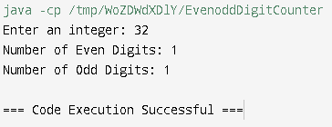

**HOME TASK 3:**

import java.util.Scanner;

public class Mathoperation {

public static void main(String[] args) {

// Input from the user

Scanner scanner = new Scanner(System.in);

System.out.print("Enter a number: ");

Double number = scanner.nextDouble();

Double abstr= Math.abs(number);

Double sqrtvalue= Math.sqrt(number);

Double powerValue= Math.pow(number,2);

System.out.println("Absolute Value:" +abstr);

System.out.println("Square Value:" +sqrtvalue);

System.out.println("Power Value:" +powerValue);

scanner.close();

}

}

**OUTPUT**

**HOME TASK 4:**

import java.util.*;

public class ReverseVowels {

// Function to check if a character is a vowel

private static boolean isVowel(char c) {

return "AEIOUaeiou".indexOf(c) != -1;

}

// Function to reverse vowels in a string

public static String reverseVowels(String str) {

char[] chars = str.toCharArray();

int left = 0, right = chars.length - 1;

while (left < right) {

// Find the next vowel from the left

while (left < right && !isVowel(chars[left])) {

left++;

}

// Find the next vowel from the right

while (left < right && !isVowel(chars[right])) {

right--;

}

// Swap the vowels

if (left < right) {

char temp = chars[left];

chars[left] = chars[right];

chars[right] = temp;

left++;

right--;

}

}

return new String(chars);

}

public static void main(String[] args) {

String input = "hello world";

System.out.println("Original String: " + input);

System.out.println("String after reversing vowels: " + reverseVowels(input));

}

}

**OUTPUT**

